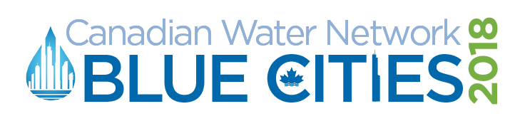

Session title: Roles, Responsibility and Resiliency
Time: 10:45am – 12:00pm, May 2, 2018
Track description:
Water as a core component of smart city design: How do we design cities with water in mind? Where are the opportunities to collaborate with other stakeholders and improve resiliency? Let’s look at the bigger picture and consider the integration of water into broader urban design.
Session description:
Many stakeholders have a role to play in ensuring community resiliency to extreme events, especially flooding. Discussions will focus on where we see our respective roles/responsibilities and on opportunities for groups to work together in a more coordinated way to ensure citizens are protected and communities are resilient. Panelists will open the conversation with perspectives on the current state of affairs, challenges related to financial risks, perspectives from the insurance sector, and examples of practical actions that can be taken.
Chair:
- Susan Ancel, Director of Stormwater Strategies, EPCOR Water Service Inc.
Board Member, Canadian Water Network
Panelists:
- Jason Thistlethwaite, Assistant Professor, School of Environment, Enterprise and Development, University of Waterloo
- Craig Stewart, Vice-President, Federal Affairs, Insurance Bureau of Canada
- Natalia Moudrak, Director, Intact Centre on Climate Adaptation

Session agenda:
10:30 | GROUP | Meet in British Columbia room to prepare and set up
10:45 | Chair: Susan | Welcome & Introduction of session by using 3-4 challenge questions:  - Many different groups and stakeholders have a role to play in ensuring community resiliency.  - What are the roles and responsibilities of different stakeholders in improving resiliency and protecting public?  - Where are opportunities to work together and with other stakeholders to help ensure that our communities are resilient and the public is informed and protected?  Introduce Jason
10:50 | Jason’s presentation  (7 minutes) | - Will set-up the problem statement  - context from existing research, flood governance arrangements, funding, etc.  - who are the actors, what is the framework, and what are their responsibilities?  - why we need to figure out these roles and responsibilities.  - Can talk a little bit about establishing governance arrangements
 | Susan | Thank  Introduce Craig
 | Craig’s presentation  (7 minutes) | - Paint a picture of challenges facing them from a financial risk perspective  - Role of insurers/insurance  - Need for a coordinated approach/ whole society approach  - Conversation with federal, provinces, and territories  - Evolving challenge for insurers and the transitory state that they’re in
 | Susan | Thank  Introduce Natalia
 | Natalia’s presentation  (7 minutes) | - Can highlight the municipal, developer, and conservation authority side of things, getting down to the homeowner.  - Role that standards and programs can play  - Practical actions, what works, and what they’ve seen from developers that are proactive
11:10 | Susan | Thanks  Open up discussion with panelists and attendees  Questions include:  - What governance arrangements are effective?  - What should an effective flood governance arrangement look like?  - How to manage and control land use in risk-prone areas?  - What should we do to protect properties of property owners?  - What is an “informed consumer” model and how can we shift to that?  - What are the relationships that you have in your community?  - How do we ensure that information on what is done municipally or at the property level is effectively communicated to and taken into account by other stakeholders?  - When do you build to avoid vs rely on insurance or disaster response?  - How can utilities influence customers to protect themselves?  - Private property flood proofing vs utilities infrastructure investment: what is the appropriate balance?  - We can’t fix everything at once - can green mitigate the risk until we get there?  - How do we ensure that information on what is done municipally or at the property level is effectively communicated to and taken into account by other stakeholders?  Other example questions
11:57 | Susan | Thank panelists  Lunch is in the ballroom, followed by the closing plenary at 1:30  Note that, for those who may have missed the posters yesterday, that there were several posters associated with this session  - A slide will be put up with the associated poster titles  - Ask any poster presenters associated with this session to stand up so people can ID them  Note that attendees can still see the posters in the ballroom during lunch.

Speaker Biographies
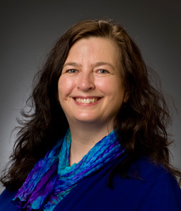
Susan Ancel
Susan is the Director of Stormwater Strategies for EPCOR Water Services Inc. This is a new role focusing on the development of an integrated resource plan for stormwater management that considers capital and operational risk mitigation planning and builds awareness of the interrelationships between utilities, insurance, disaster response agencies and the public in preparing and responding to changing stormwater risks. Previously, Susan was the Director of Water Distribution and Transmission at EPCOR, and was responsible for the planning, engineering, construction, operation and maintenance of the water distribution and metering in Edmonton. Susan is currently a Board member for Canadian Water Network and has also served on numerous industry committees.

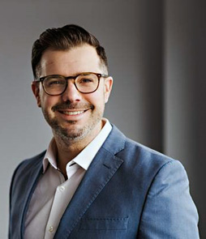
Jason Thistlethwaite
Jason Thistlethwaite is an Assistant Professor in the School of Environment, Enterprise and Development at the University of Waterloo. His research focuses on climate change and flood risk governance and more specifically on the strategies and tools that property owners and local governments use to reduce economic vulnerability at the local level. His current research is building data-driven 3D visualizations of flood risk in future climates to inform governments about effective risk management strategies. These findings have been published in numerous academic and industry journals and is supported by government and private sector funding.

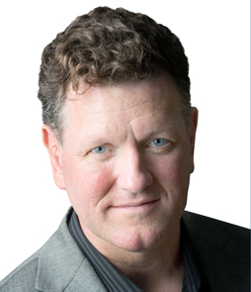
Craig Stewart
Craig is Vice President of Federal Affairs for the Insurance Bureau of Canada, where he leads national work on disaster resilience and climate change. IBC represents the property and casualty insurance industry in Canada and paid out $9.8 billion in property claims in 2016, primarily due to severe weather and wildfire. Previous to his work with IBC, Craig directed the Ottawa Bureau and Arctic Program for World Wildlife Fund Canada and directed a $60 million federal/provincial/territorial program at Natural Resources Canada to elevate the Canadian geospatial industry. Craig also founded the Miistakis Institute at the University of Calgary. He is also the author of two atlases.

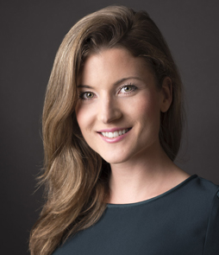
Natalia Moudrak
Natalia Moudrak is Director of the Infrastructure Adaption Program at the Intact Centre on Climate Adaption. She advances the development of guidelines and standards for building flood-resilient communities in Canada and advocates for the preservation of natural infrastructure as a key climate change adaptation solution. Previously, Natalia worked at PricewaterhouseCoopers Canada in Risk Assurance Services. Natalia is a recipient of the 2018 Canada’s Clean50 Emerging Leader award. She is also a member of the Canadian Water and Wastewater Association’s climate change committee and the National Research Council’s committee on flood resilience.

